**Q. Write a program to get the selected value and currently selected text of a dropdown box using jQuery.**

**CODE:**

<!DOCTYPE html>

<html lang="en">

<head>

<meta charset="UTF-8">

<title>Option</title>

<script src="https://ajax.googleapis.com/ajax/libs/jquery/3.6.4/jquery.min.js"></script>

</head>

<div>

<p>The selected value: </p>

<select id="myselection">

<option value="1">First</option>

<option value="2">Second</option>

<option value="3">Third</option>

</select>

<br>

<button id="submit">Submit</button>

</div>

<script>

$(document).ready(function () {

$("#submit").click(function () {

alert($("#myselection").val());

});

});

</script>

</html>

**OUTPUT:**

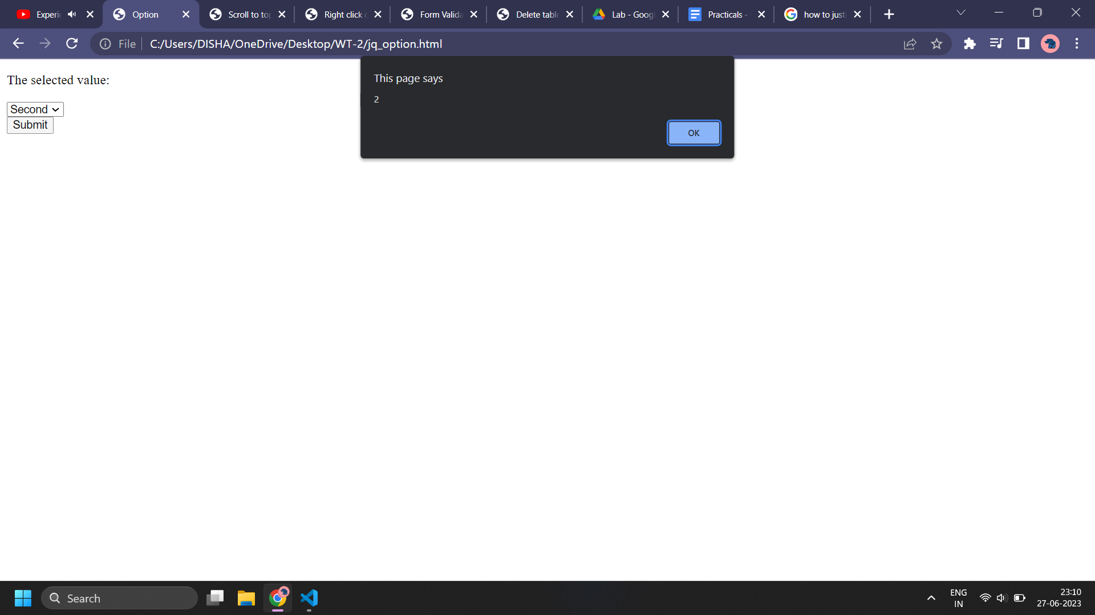

**Q. Write a program to scroll on top of the page using jQuery.**

**CODE:**

<!DOCTYPE html>

<html lang="en">

<head>

<meta charset="UTF-8">

<meta name="viewport" content="width=device-width, initial-scale=1.0">

<title>Scroll to top</title>

<script src="https://ajax.googleapis.com/ajax/libs/jquery/3.6.4/jquery.min.js"></script>

</head>

<body>

<p>Lorem ipsum dolor sit amet consectetur adipisicing elit. Itaque velit quidem dicta? Numquam fugit sint quia

consequatur dolorum possimus assumenda. Laborum consectetur optio libero neque quas officiis quae voluptate

quod.

</p>

<a href="#top">Go to top</a>

</body>

<script>

$("a[href='#top']").click(function () {

$("html, body").animate({ scrollTop: 0 }, "slow");

return false;

});

</script>

</html>

**OUTPUT:**

